Identifying safe loans with decision trees

Summary / Observations:
The Lending Club is a peer-to-peer leading company that directly connects borrowers and potential lenders/investors. Built a classification model to predict whether or not a loan provided by Lending Club is likely to default.
Tasks:

- Used data from the Lending Club to predict whether a loan will be paid off in full or the loan will be charged off and possibly go into default.
- Used SFrames to do some feature engineering.
- Trained a decision-tree on the Lending Club dataset.
- Visualized the tree.
- Predicted whether a loan will default along with prediction probabilities (on a validation set).
- Trained a complex tree model and compare it to simple tree model.

Visualizations:
Visualizing the prediction on a tree by traversing a point from the sample validation data and visualize the prediction being made.
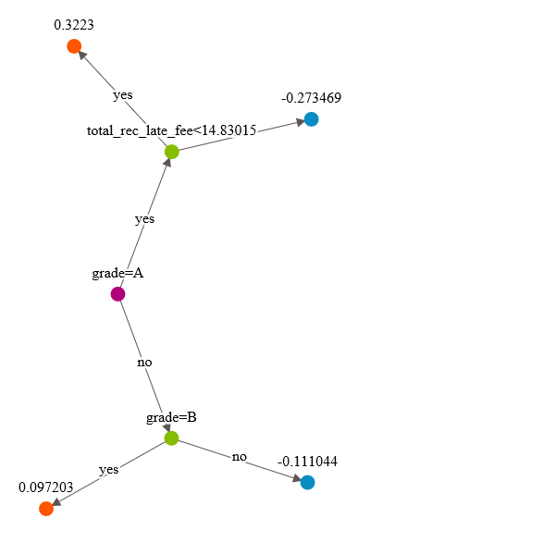
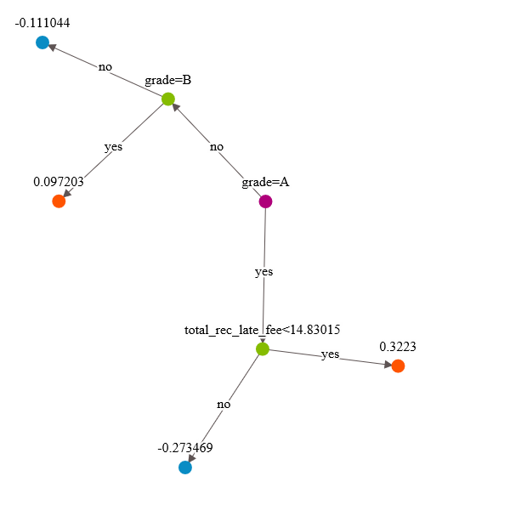
Note: In the tree visualization above, the values at the leaf nodes are not class predictions but scores.If the score is ≥ 0, the class +1 is predicted. Otherwise, if the score < 0, we predict class -1.
Evaluation of Decision Tree Model
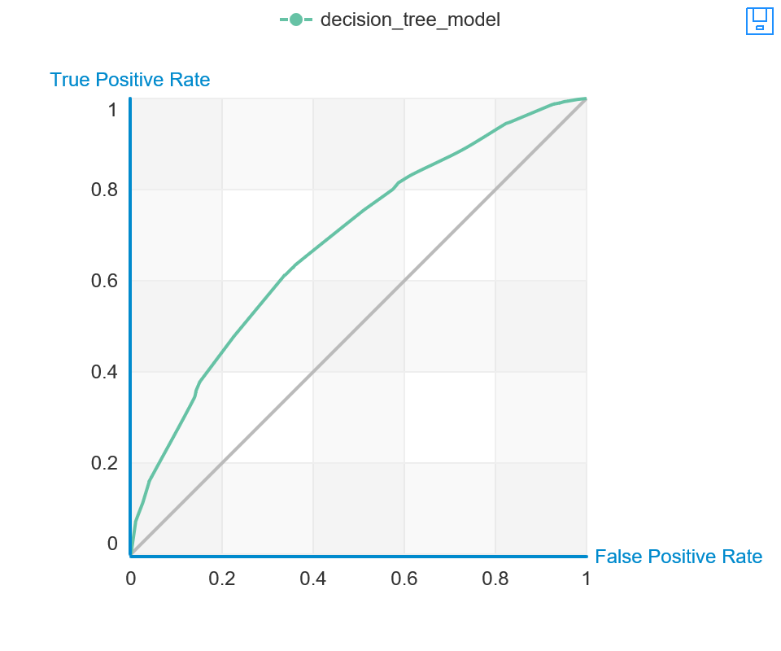
True Positive | False Negative | Accuracy | Precision
0 | 4610 | 0.503 | NaN
False Positive | True Negative | Recall | F1 Score
0 | 4674 | 0 | 0

Threshold
0.668

AUC
0.685

General Metrics
f1_score | 0.632
auc | 0.684
recall | 0.628
precision | 0.636
log_loss | 0.665
accuracy | 0.637
- Assume a cost of $10,000 per false negative.
- Assume a cost of $20,000 per false positive.
Findings: The total cost of mistakes made by decision_tree_model on validation_data
No. of Mistakes: 1716
Total Cost of Mistakes: 50280000
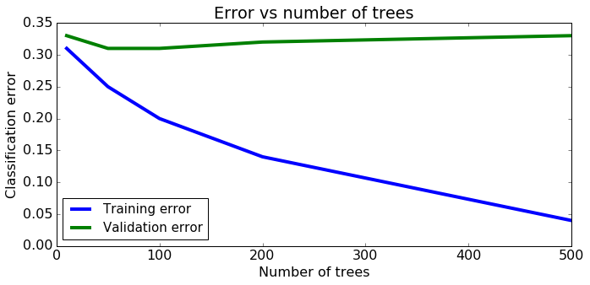
The training error reduce as the number of trees increases.
The validation error will not reduce as the number of trees increases.
Observations:
- Sampled data to balance classes, as our data is disproportionally Note:
- Manage Imbalanced data -There are many approaches for dealing with imbalanced data, including some where we modify the learning algorithm. Used the simplest possible approach, where we subsample the overly represented class to get a more balanced dataset. In general, and especially when the data is highly imbalanced, it is recommended to use more advanced methods.
- The portion of data that we don't train on will be used to help select model parameters (this is known as model selection). Thus, this portion of data should be called a validation set. Recall that examining performance of various potential models (i.e. models with different parameters) should be on validation set, while evaluation of the final selected model should always be on test data.
- Quantifying the cost of mistakes¶-Every mistake the model makes costs money. In this section, we will try and quantify the cost of each mistake made by the model.
- Assume the following:
- False negatives: Loans that were actually safe but were predicted to be risky. This results in an opportunity cost of losing a loan that would have otherwise been accepted.
- False positives: Loans that were actually risky but were predicted to be safe. These are much more expensive because it results in a risky loan being given.
- Correct predictions: All correct predictions don't typically incur any cost.
Implementing binary decision trees
- The goal of this assignment is to implement our own binary decision tree classifier.
- Used SFrames to do some feature engineering.
- Transformed categorical variables into binary variables.
- Built a binary decision tree from scratch.
- Made predictions using the decision tree.
- Evaluated the accuracy of the decision tree.
- Visualized the decision at the root node.
- Important Note: In this assignment, we will focus on building decision trees where the data contain only binary (0 or 1) features. This allows us to avoid dealing with:
- Multiple intermediate nodes in a split
- The thresholding issues of real-valued features.
Decision Trees in Practice
- Implement binary decision trees with different early stopping methods.
- Compared models with different stopping parameters.
- Visualized the concept of overfitting in decision trees.
Gradient boosted tree classifier
Tasks:
- Explored Ensemble Methods
- Explored the use of boosting.
- Used the pre-implemented gradient boosted trees in Graphlab-Create.
- Used SFrames to do some feature engineering.
- Trained a boosted ensemble of decision-trees (gradient boosted trees) on the lending club dataset.
- Predicted whether a loan will default along with prediction probabilities (on a validation set).
- Evaluated the trained model and compare it with a baseline.
- Found the most positive and negative loans using the learned model.
- Explored how the number of trees influences classification performance.
- Plotted the training and validation error vs. number of trees
Observations:
- In the earlier assignment, we saw that the prediction accuracy of the decision trees was around 0.64 (rounded). In this assignment, we saw that model_5 has an accuracy of 0.67 (rounded).
- Here, we quantify the benefit of the extra 3% increase in accuracy of model_5 in comparison with a single decision tree from the original decision tree assignment.
- Reminder: Compare the cost of the mistakes made by the boosted trees model with the decision tree model. The extra 3% improvement in prediction accuracy can translate to several million dollars! And, it was so easy to get by simply boosting our decision trees.
Boosting a decision stump
Tasks:
- Implement our own boosting module. A fun and challenging assignment.
- Used SFrames to do some feature engineering.
- Trained a boosted ensemble of decision-trees (gradient boosted trees) on the lending club dataset.
- Predicted whether a loan will default along with prediction probabilities (on a validation set).
- Evaluated the trained model and compare it with a baseline.
- Found the most positive and negative loans using the learned model.
- Explored how the number of trees influences classification performance.
Observations:
- The model small_data_decision_tree_subset_20 performs a lot better on subset_20 than on train_data which means - The points with higher weights are the ones that are more important during the training process of the weighted decision tree.
- The points with zero weights are basically ignored during training.
- Stump weights (ŵ ) and data point weights (α) are two different concepts. Stump weights (ŵ ) tell us how important each stump is while making predictions with the entire boosted ensemble.
- Data point weights (α) tell us how important each data point is while training a decision stump.

ASSIGNMENT4:

Identifying safe loans with decision trees
The Lending Club is a peer-to-peer leading company that directly connects borrowers and potential lenders/investors. In this notebook, you will build a classification model to predict whether or not a loan provided by Lending Club is likely to default.
In this notebook you will use data from the Lending Club to predict whether a loan will be paid off in full or the loan will be charged off and possibly go into default. In this assignment you will:
- Use SFrames to do some feature engineering.
- Train a decision-tree on the Lending Club dataset.
- Visualize the tree.
- Predict whether a loan will default along with prediction probabilities (on a validation set).
- Train a complex tree model and compare it to simple tree model.
Write-Up / Pseudo Code:
- Load Lending Club Dataset
- Quickly explore some features of the dataset.
- Exploring the target column and in order to make this more intuitive and consistent with the lectures, we reassign the target to be:
  - +1 as a safe loan,
  - -1 as a risky (bad) loan.
We put this in a new column called safe loans.
- Explore the distribution of the column safe_loans. This gives us a sense of how many safe and risky loans are present in the dataset.
- It showed:
  - Around 81% safe loans
  - Around 19% risky loans
It looks like most of these loans are safe loans (thankfully). But this does make our problem of identifying risky loans challenging.
- We will be using a subset of features (categorical and numeric).
- Sample data to balance classes, as we explored above, our data is disproportionally full of safe loans.
Note:

MANAGE IMBALANCED DATA:
Note: There are many approaches for dealing with imbalanced data, including some where we modify the learning algorithm. These approaches are beyond the scope of this course, but some of them are reviewed in this paper. For this assignment, we use the simplest possible approach, where we subsample the overly represented class to get a more balanced dataset. In general, and especially when the data is highly imbalanced, we recommend using more advanced methods.
E.g. # Since there are fewer risky loans than safe loans, find the ratio of the sizes, and use that percentage to under sample the safe loans.
Split data into training and validation sets
Note: However, the portion of data that we don't train on will be used to help select model parameters (this is known as model selection). Thus, this portion of data should be called a validation set. Recall that examining performance of various potential models (i.e. models with different parameters) should be on validation set, while evaluation of the final selected model should always be on test data.

- Sample data to balance classes, as we explored above, our data is disproportionally full of safe loans.
- Use Decision tree to build a classifier.
Code:
decision_tree_model = graphlab.decision_tree_classifier.create(train_data,validation_set=None, target = target, features = features)
- Visualizing a learned model. [Typically the max depth of the tree is capped at 6]. We instead learn a smaller model with max depth of 2 to gain some intuition by visualizing the learned tree.
small_model.show(view="Tree")
- Making Predictions- Let's consider two positive and two negative examples from the validation set and see what the model predicts. We will do the following:
  - Predict whether or not a loan is safe.
  - Predict the probability that a loan is safe.
- Explore Label predictions for the above sample data - decision_tree_model.predict(sample_validation_data)
- Explore Probability predictions for the above sample data
  - decision_tree_model.predict(sample_validation_data,output_type='probability')
- Visualize the prediction on a tree with a point in the sample validation data.
- Evaluating the accuracy of the decision tree model [Both small_model and decision_tree_model]
  - Recall that the accuracy is defined as follows:
accuracy=# correctly classified examples/# total examples
Code:
print small_model.evaluate(train_data)['accuracy']
print decision_tree_model.evaluate(train_data)['accuracy']
- Evaluating accuracy of a complex decision tree model. Here, we will train a large decision tree with max_depth=10. This will allow the learned tree to become very deep, and result in a very complex model.
big_model = graphlab.decision_tree_classifier.create(train_data, validation_set=None,
target = target, features = features, max_depth = 10)
Checkpoint: We should see that big_model has even better performance on the training set than decision_tree_model did on the training set.
- Quantifying the cost of mistakes¶-Every mistake the model makes costs money. In this section, we will try and quantify the cost of each mistake made by the model.

Assume the following:
- False negatives: Loans that were actually safe but were predicted to be risky. This results in an oppurtunity cost of losing a loan that would have otherwise been accepted.
- False positives: Loans that were actually risky but were predicted to be safe. These are much more expensive because it results in a risky loan being given.
- Correct predictions: All correct predictions don't typically incur any cost.

Code:
decision_tree_model.show(view='Evaluation')
false_positives = (validation_data[validation_data['safe_loans'] != predictions]['safe_loans'] == -1).sum()
print false_positives
false_negatives = (validation_data[validation_data['safe_loans'] != predictions]['safe_loans'] == +1).sum()
print false_negatives
cost_of_mistakes = (false_negatives * 10000) + (false_positives * 20000)
print cost_of_mistakes

ASSIGNMENT5:

Implementing binary decision trees
The goal of this notebook is to implement your own binary decision tree classifier. You will:
- Use SFrames to do some feature engineering.
- Transform categorical variables into binary variables.
- Write a function to compute the number of misclassified examples in an intermediate node.
- Write a function to find the best feature to split on.
- Build a binary decision tree from scratch.
- Make predictions using the decision tree.
- Evaluate the accuracy of the decision tree.
- Visualize the decision at the root node.
Important Note: In this assignment, we will focus on building decision trees where the data contain only binary (0 or 1) features. This allows us to avoid dealing with:
- Multiple intermediate nodes in a split
- The thresholding issues of real-valued features.
Write Up / Pseudo Code:
- Load Lending Club Dataset
- Re assign the labels to have +1 for a safe loan, and -1 for a risky (bad) loan.
- Unlike the previous assignment where we used several features, in this assignment, we will just be using 4 categorical features:
  - grade of the loan
  - the length of the loan term
  - the home ownership status: own, mortgage, rent
  - number of years of employment.
Since we are building a binary decision tree, we will have to convert these categorical features to a binary representation in a subsequent section using 1-hot encoding.
- Subsample dataset to make sure classes are balanced.

Note: There are many approaches for dealing with imbalanced data, including some where we modify the learning algorithm. These approaches are beyond the scope of this course, but some of them are reviewed in "Learning from Imbalanced Data" by Haibo He and Edwardo A. Garcia, IEEE Transactions on Knowledge and Data Engineering 21(9) (June 26, 2009), p. 1263–1284. For this assignment, we use the simplest possible approach, where we subsample the overly represented class to get a more balanced dataset. In general, and especially when the data is highly imbalanced, we recommend using more advanced methods.
- Transform categorical data into binary features¶

In this assignment, we will implement binary decision trees (decision trees for binary features, a specific case of categorical variables taking on two values, e.g., true/false). Since all of our features are currently categorical features, we want to turn them into binary features.
For instance, the home_ownership feature represents the home ownership status of the loanee, which is either own, mortgage or rent. For example, if a data point has the feature
{'home_ownership': 'RENT'}
we want to turn this into three features:
{
'home_ownership = OWN' : 0,
'home_ownership = MORTGAGE' : 0,
'home_ownership = RENT' : 1
}
- Train-Test Split: We split the data into a train test split with 80% of the data in the training set and 20% of the data in the test set. We use seed=1 so that everyone gets the same result.
- Decision tree implementation
  - Function to count number of mistakes while predicting majority class.
  - Function to pick best feature to split on
  - The function best_splitting_feature takes 3 arguments:
    - The data (SFrame of data which includes all of the feature columns and label column)
    - The features to consider for splits (a list of strings of column names to consider for splits)
    - The name of the target/label column (string)
  - Follow these steps:
    - Step 1: Loop over each feature in the feature list
    - Step 2: Within the loop, split the data into two groups: one group where all of the data has feature value 0 or False (we will call this the left split), and one group where all of the data has feature value 1 or True (we will call this the right split). Make sure the left split corresponds with 0 and the right split corresponds with 1 to ensure your implementation fits with our implementation of the tree building process.
    - Step 3: Calculate the number of misclassified examples in both groups of data and use the above formula to compute the classification error.
    - Step 4: If the computed error is smaller than the best error found so far, store this feature and its error.
    - This may seem like a lot, but we have provided pseudocode in the comments in order to help you implement the function correctly.
    - Note: Remember that since we are only dealing with binary features, we do not have to consider thresholds for real-valued features. This makes the implementation of this function much easier.
- Building the tree
  - With the above functions implemented correctly, we are now ready to build our decision tree. Each node in the decision tree is represented as a dictionary which contains the following keys and possible values:
{
'is_leaf' : True/False.
'prediction' : Prediction at the leaf node.
'left' : (dictionary corresponding to the left tree).
'right' : (dictionary corresponding to the right tree).
'splitting_feature' : The feature that this node splits on.
}
- We have provided a function that learns the decision tree recursively and implements 3 stopping conditions:
  - Stopping condition 1: All data points in a node are from the same class.
  - Stopping condition 2: No more features to split on.
  - Additional stopping condition: In addition to the above two stopping conditions covered in lecture, in this assignment we will also consider a stopping condition based on the max_depth of the tree. By not letting the tree grow too deep, we will save computational effort in the learning process.
- Build the tree with max_depth=6 - my_decision_tree=decision_tree_create(train_data, features, 'safe_loans', max_depth = 6)
- Make predictions with the decision tree.
- Evaluating your decision tree.
- Explored the intermediate, left and right sub trees.

ASSIGNMENT6:

Decision Trees in Practice
In this assignment we will explore various techniques for preventing overfitting in decision trees. We will extend the implementation of the binary decision trees that we implemented in the previous assignment. You will have to use your solutions from this previous assignment and extend them.
In this assignment you will:
- Implement binary decision trees with different early stopping methods.
- Compare models with different stopping parameters.
- Visualize the concept of overfitting in decision trees.
Write Up:
- Load LendingClub Dataset
- Subsample dataset to make sure classes are balanced
- Transform categorical data into binary features
- Train-Validation split
- Early stopping methods for decision trees¶
In this section, we will extend the binary tree implementation from the previous assignment in order to handle some early stopping conditions. Recall the 3 early stopping methods that were discussed in lecture:
  - Reached a maximum depth. (set by parameter max_depth).
  - Reached a minimum node size. (set by parameter min_node_size).
  - Don't split if the gain in error reduction is too small. (set by parameter min_error_reduction).
- Early stopping condition 1: Maximum depth
- Recall that we already implemented the maximum depth stopping condition in the previous assignment.
- Early stopping condition 2: Minimum node size
The function reached_minimum_node_size takes 2 arguments:
  - The data (from a node)
  - The minimum number of data points that a node is allowed to split on, min_node_size.
This function simply calculates whether the number of data points at a given node is less than or equal to the specified minimum node size. This function will be used to detect this early stopping condition in the decision_tree_create function.
- Early stopping condition 3: Minimum gain in error reduction¶
The function error_reduction takes 2 arguments:
  - The error before a split, error_before_split.
  - The error after a split, error_after_split.
This function computes the gain in error reduction, i.e., the difference between the error before the split and that after the split. This function will be used to detect this early stopping condition in the decision_tree_create function.
- Implementing early stopping condition 2: minimum node size:
- Step 1: Use the function reached_minimum_node_size that you implemented earlier to write an if condition to detect whether we have hit the base case, i.e., the node does not have enough data points and should be turned into a leaf. Don't forget to use the min_node_size argument.
- Step 2: Return a leaf. This line of code should be the same as the other (pre-implemented) stopping conditions.
- Implementing early stopping condition 3: minimum error reduction:
- Note: This has to come after finding the best splitting feature so we can calculate the error after splitting in order to calculate the error reduction.
- Step 1: Calculate the classification error before splitting. Recall that classification error is defined as:
- classification error=# mistakes# total examples
- Step 2: Calculate the classification error after splitting. This requires calculating the number of mistakes in the left and right splits, and then dividing by the total number of examples.
- Step 3: Use the function error_reduction to that you implemented earlier to write an if condition to detect whether the reduction in error is less than the constant provided (min_error_reduction). Don't forget to use that argument.
- Step 4: Return a leaf. This line of code should be the same as the other (pre-implemented) stopping conditions.
- Build a tree
Code: my_decision_tree_new = decision_tree_create(train_data, features, 'safe_loans', max_depth = 6, min_node_size = 100, min_error_reduction=0.0)
- Making Predictions
- Evaluate the Model
- Explore the effect of Max Depth
We will compare three models trained with different values of the stopping criterion. We intentionally picked models at the extreme ends (too small, just right, and too large).
Train three models with these parameters:
- model_1: max_depth = 2 (too small)
- model_2: max_depth = 6 (just right)
- model_3: max_depth = 14 (may be too large)
- Measuring the complexity of the tree
Deeper trees being more complex. We will measure the complexity of the tree as
complexity(T) = number of leaves in the tree T
- Exploring the effect of min_error¶
We will compare three models trained with different values of the stopping criterion. We intentionally picked models at the extreme ends (negative, just right, and too positive).
Train three models with these parameters:
- model_4: min_error_reduction = -1 (ignoring this early stopping condition)
- model_5: min_error_reduction = 0 (just right)
- model_6: min_error_reduction = 5 (too positive)
- Exploring the effect of min_node_size¶
We will compare three models trained with different values of the stopping criterion. Again, intentionally picked models at the extreme ends (too small, just right, and just right).
Train three models with these parameters:
- model_7: min_node_size = 0 (too small)
- model_8: min_node_size = 2000 (just right)
- model_9: min_node_size = 50000 (too large)

ASSIGNMENT7:

Gradient boosted tree classifier

Exploring Ensemble Methods
In this homework we will explore the use of boosting. For this assignment, we will use the pre-implemented gradient boosted trees in Graphlab-Create. You will:
Use SFrames to do some feature engineering.
- Train a boosted ensemble of decision-trees (gradient boosted trees) on the lending club dataset.
- Predict whether a loan will default along with prediction probabilities (on a validation set).
- Evaluate the trained model and compare it with a baseline.
- Find the most positive and negative loans using the learned model.
- Explore how the number of trees influences classification performance.

Write up / Pseudo Code:
- Load Lending Club dataset
- Modify the target Column in order to make this more intuitive and consistent with the lectures, we reassign the target to be.
- Select a subset of features (categorical and numeric).
- Skipping observations with missing values
- Recall from the lectures that one common approach to coping with missing values is to skip observations that contain missing values.
- Make sure the classes are balanced- an earlier assignment that this dataset is also imbalanced. We will undersample the larger class (safe loans) in order to balance out our dataset.
- Split data into training and validation sets
- Gradient boosted tree classifier- Gradient boosted trees are a powerful variant of boosting methods; they have been used to win many Kaggle competitions, and have been widely used in industry.
- In this section, we will experiment with training an ensemble of 5 trees. To cap the ensemble classifier at 5 trees, we call the function with max_iterations=5 (recall that each iterations corresponds to adding a tree). We set validation_set=None to make sure everyone gets the same results.
Code:
model_5 = graphlab.boosted_trees_classifier.create(train_data, validation_set=None, target = target, features = features, max_iterations = 5)
- Making predictions
- Make predictions for a few positive and negative examples from the validation set. We will do the following:
  - Predict whether or not a loan is likely to default.
  - Predict the probability with which the loan is likely to default.

Code:
samplepred=model_5.predict(sample_validation_data)
print model_5.predict(sample_validation_data,output_type='probability')
Checkpoint: Can you verify that for all the predictions with probability >= 0.5, the model predicted the label +1?
- Evaluating the model on the validation data
- Recall that the accuracy is defined as follows:
accuracy=# correctly classified examples/# total examples
Code:
print model_5.evaluate(validation_data)
False Positives:
false_positives=sum(model_5.predict(validation_risky_loans)== +1)
False Negatives:
false_negatives=sum(model_5.predict(validation_safe_loans)== -1)
- Comparison with decision trees
In the earlier assignment, we saw that the prediction accuracy of the decision trees was around 0.64 (rounded). In this assignment, we saw that model_5 has an accuracy of 0.67 (rounded).
Here, we quantify the benefit of the extra 3% increase in accuracy of model_5 in comparison with a single decision tree from the original decision tree assignment.
As we explored in the earlier assignment, we calculated the cost of the mistakes made by the model. We again consider the same costs as follows:
False negatives: Assume a cost of $10,000 per false negative.
False positives: Assume a cost of $20,000 per false positive.
Assume that the number of false positives and false negatives for the learned decision tree was
False negatives: 1936
False positives: 1503
Using the costs defined above and the number of false positives and false negatives for the decision tree, we can calculate the total cost of the mistakes made by the decision tree model as follows:
cost = $10,000 * 1936 + $20,000 * 1503 = $49,420,000
The total cost of the mistakes of the model is $49.42M. That is a lot of money!.
Cost here:
cost = (10000 * false_negatives) + (20000 * false_positives)
print cost
46990000

Reminder: Compare the cost of the mistakes made by the boosted trees model with the decision tree model. The extra 3% improvement in prediction accuracy can translate to several million dollars! And, it was so easy to get by simply boosting our decision trees.
- Find Most positive & negative loans.
In this section, we will find the loans that are most likely to be predicted safe. We can do this in a few steps:
  - Step 1: Use the model_5 (the model with 5 trees) and make probability predictions for all the loans in the validation_data.
  - Step 2: Similar to what we did in the very first assignment, add the probability predictions as a column called predictions into the validation_data.
  - Step 3: Sort the data (in descreasing order) by the probability predictions.
Start here with Step 1 & Step 2. Make predictions using model_5 for examples in the validation_data. Use output_type = probability.

Checkpoint: For each row, the probabilities should be a number in the range [0, 1]. We have provided a simple check here to make sure your answers are correct.

- Effect of adding more trees
- In this assignment, we will train 5 different ensemble classifiers in the form of gradient boosted trees. We will train models with 10, 50, 100, 200, and 500 trees. We use the max_iterations parameter in the boosted tree module.
Let's get sarted with a model with max_iterations = 10:

model_10 = graphlab.boosted_trees_classifier.create(train_data, validation_set=None,
target = target, features = features, max_iterations = 10, verbose=False)

Now, train 4 models with max_iterations to be:
max_iterations = 50,
max_iterations = 100
max_iterations = 200
max_iterations = 500.
Let us call these models model_50, model_100, model_200, and model_500. You can pass in verbose=False in order to suppress the printed output.
- Compare accuracy on entire validation set
- Now we will compare the predicitve accuracy of our models on the validation set. Evaluate the accuracy of the 10, 50, 100, 200, and 500 tree models on the validation_data. Use the .evaluate method.
m.evaluate(validation_data)['accuracy']
Quiz Question: Which model has the best accuracy on the validation_data? Answer:Model_100 - 0.6917277035760449
Is it always true that the model with the most trees will perform best on test data? No
- Plot the training and validation error vs. number of trees
Recall from the lecture that the classification error is defined as classification error=1−accuracy

ASSIGNMENT 8:

Boosting a decision stump
In this homework you will implement your own boosting module.
Brace yourselves! This is going to be a fun and challenging assignment.
- Use SFrames to do some feature engineering.
- Train a boosted ensemble of decision-trees (gradient boosted trees) on the lending club dataset.
- Predict whether a loan will default along with prediction probabilities (on a validation set).
- Evaluate the trained model and compare it with a baseline.
- Find the most positive and negative loans using the learned model.
- Explore how the number of trees influences classification performance.

Write Up / Pseudo Code:
- Load the Data from LendingClub dataset
- Extract the target and feature columns as below:
  - we re-assign the target to have +1 as a safe (good) loan, and -1 as a risky (bad) loan.
  - Next, we select four categorical features:
    - grade of the loan
    - the length of the loan term
    - the home ownership status: own, mortgage, rent
    - number of years of employment.
- Subsample dataset to make sure classes are balanced
- Transform categorical data into binary features -
  - In this assignment, we will work with binary decision trees. Since all of our features are currently categorical features, we want to turn them into binary features using 1-hot encoding.
- Train-test split
- Write a function to compute weight of mistakes
- Write a function that calculates the weight of mistakes for making the "weighted-majority" predictions for a dataset. The function accepts two inputs:
labels_in_node: Targets y1...yn
data_weights: Data point weights α1...αn
We are interested in computing the (total) weight of mistakes, i.e.
WM(α,ŷ )=∑i=1nαi×1[yi≠yi^].
This quantity is analogous to the number of mistakes, except that each mistake now carries different weight. It is related to the weighted error in the following way:
E(α,ŷ )=WM(α,ŷ )∑ni=1αi
The function intermediate_node_weighted_mistakes should first compute two weights:
- WM−1 : weight of mistakes when all predictions are ŷ i=−1 i.e WM(α,−1 )
- WM+1 : weight of mistakes when all predictions are ŷ i=+1 i.e WM(α,+1 )
where −1 and +1 are vectors where all values are -1 and +1 respectively.
After computing WM−1 and WM+1 , the function intermediate_node_weighted_mistakes should return the lower of the two weights of mistakes, along with the class associated with that weight.
- Write a Function to pick best feature to split on¶
  - We continue modifying our decision tree code from the earlier assignment to incorporate weighting of individual data points. The next step is to pick the best feature to split on.
    - The best_splitting_feature function is similar to the one from the earlier assignment with two minor modifications:
    - The function best_splitting_feature should now accept an extra parameter data_weights to take account of weights of data points.
    - Instead of computing the number of mistakes in the left and right side of the split, we compute the weight of mistakes for both sides, add up the two weights, and divide it by the total weight of the data.
Pseudo-code:
    - Loop through each feature to consider splitting on that feature
    - Apply the same filtering to data_weights to create left_data_weights, right_data_weights
    - Calculate the weight of mistakes for left and right sides using intermediate_node_weighted_mistakes
    - Compute weighted error by computing
# ( [weight of mistakes (left)] + [weight of mistakes (right)] ) / [total weight of all data points]
    - If this is the best error we have found so far, store the feature and the error

- Build the tree with weighted_decision_tree_create.
We provide a function that learns a weighted decision tree recursively and implements 3 stopping conditions:
  - All data points in a node are from the same class.
  - No more features to split on.
  - Stop growing the tree when the tree depth reaches max_depth.
- Predict and Evaluate the tree
Note:
- The model small_data_decision_tree_subset_20 performs a lot better on subset_20 than on train_data.
- So, what does this mean?
- The points with higher weights are the ones that are more important during the training process of the weighted decision tree.
- The points with zero weights are basically ignored during training.
- Implementing your own Adaboost (on decision stumps) - adaboost_with_tree_stumps
- Checking the Adaboost code¶.
  - Train an ensemble of two tree stumps and see which features those stumps split on. We will run the algorithm with the following parameters:
    - train_data
    - features
    - target
    - num_tree_stumps = 2
Code:
stump_weights, tree_stumps = adaboost_with_tree_stumps(train_data, features, target, num_tree_stumps=2)
Important Reminders:
  - Stump weights (ŵ ) and data point weights (α) are two different concepts.
  - Stump weights (ŵ ) tell you how important each stump is while making predictions with the entire boosted ensemble.
  - Data point weights (α) tell you how important each data point is while training a decision stump.
- Training a boosted ensemble of 10 stumps and making predictions.
- Computing training error at the end of each iteration
error_all = []
for n in xrange(1, 31):
predictions = predict_adaboost(stump_weights[:n], tree_stumps[:n], train_data)
error = 1.0 - graphlab.evaluation.accuracy(train_data[target], predictions)
error_all.append(error)
print "Iteration %s, training error = %s" % (n, error_all[n-1])
- Visualizing training error vs number of iterations
- Evaluate on the test data
test_error_all = []
for n in xrange(1, 31):
predictions = predict_adaboost(stump_weights[:n], tree_stumps[:n], test_data)
error = 1.0 - graphlab.evaluation.accuracy(test_data[target], predictions)
test_error_all.append(error)
print "Iteration %s, test error = %s" % (n, test_error_all[n-1])
- Visualize both the training and test errors

